**VIJAYAGIRI PUBLIC SCHOOL**

**JUBILEE NAGAR, ASHTAMICHIRA , ANNALLUR P O, CHALAKUDY -680731 KERALA**



**CERTIFICATE**

Certified that this is the bonafide record of project

work on …….Computer Science ……. done by

..Adwaith HR, Akshay KS, and Alfred Davis………

of class XII in accordance with the requirement

for AISSCE in project work for the year 2020 -21.

Date:

**Internal Examiner External Examiner Principal**

**CENTRAL BOARD OF SECONDARY EDUCATION**

**NEW DELHI**



**VIJAYAGIRI PUBLIC SCHOOL**

**(AFFILIATED TO CBSE, NEW DELHI – 930543)**

**JUBILEE NAGAR, ASHTAMICHIRA , ANNALLUR P O, CHALAKUDY – 680731**

**KERALA.**

**Submitted by,**

**Adwaith HR,Akshay KS,Alfred Davis**

**XII A**

**DEPARTMENT OF Computer Science**

**PROJECT: 2020 -21**

**ACKNOWLEDGEMENT**

I express my immense gratitude to the **VIJAYAGIRI PUBLIC SCHOOL**, for providing me the opportunity for conducting this project.

I am grateful to **Mr. N M GEORGE, Principal, Vijayagiri Public School**, for his valuable suggestions and inspiration throughout this work.

My special thanks to **Mrs Lali Varghese** for the guidance, worthy remarks, help and support to improve my project work.

I am thankful to my parents and all teachers for their valuable suggestions.

**INTRODUCTION**

This project is developed from a perspective of a rental car service dealer. We chose this topic to bring about the best from a Python –Mysql interface and also keeping it simple and understandable. The menu interface is made simple so that anyone could easily use all of the available choices.

**AIM**

Aim of this Car rental Service program is to allow users easily rent or return cars. There is also a choice to add cars into the collection where the users will be rewarded once it is rented. A list of available and unavailable cars is there for a better selection

**RENTAL CAR SERVICE**

* SOURCE CODE:

import  mysql.connector as sql  
conn=sql.connect(host='localhost',user='root',passwd='1999',database='vps')  
cur = conn.cursor()  
print("=========================WELCOME TO YOLA'S CAR SERVICE========================")  
def scar():  
    print("SLNO, CARNAME, RATE/DAY, DATE  OF TAKING THE CAR")  
    cur.execute('select slno,carname,rate,takedate from rentcar')  
    b=cur.fetchall()  
    for x in b:  
        print(x)  
def rentcar():  
     
    from datetime import date  
    tdate=date.today()  
  
    a=input("                    Enter the name of car: ")  
    b=input("                   Enter your name: ")  
    c=int(input("             Enter phonenumber: "))  
    cur.execute("update rentcar set status='notavailable' where carname='"+a+"'")  
    cur.execute("update rentcar set reciever='"+b+"' where carname='"+a+"'")  
    cur.execute("update rentcar set phoneno='"+str(c)+"' where carname='"+a+"'")  
    cur.execute("update rentcar set takedate='"+str(tdate)+"' where carname='"+a+"'")  
    conn.commit()  
    print("thankyou for taking the car:",a)  
  
def rcar():  
    from datetime import date  
    from datetime import timedelta  
    rdate=date.today()  
    a=input("                 enter name  of car:")  
    cur.execute("select takedate from rentcar where carname='"+a+"'")  
    b=cur.fetchall()  
    x=b[0]  
    y=x[0]  
    cur.execute("select rate from rentcar where carname='"+a+"'")  
    c=cur.fetchall()  
    g=c[0]  
    h=g[0]  
    conn.commit()  
    d=rdate-y  
    print("today's date is ",date.today())  
     
    i= int(input("how many days the car was with you"))  
     
    print("amount to pay Rs.",i*h)  
     
    print("thank you for returning the car",a)  
  
  
  
def acar():  
    
    a=input("                enter name of car         :")  
    cur.execute("select max(slno) from rentcar")  
    c=cur.fetchall()  
    d=c[0]  
    e=d[0]+1  
    f=input("enter the rate of car/day")  
    cur.execute("insert into rentcar (slno,carname,rate)  values ("+str(e)+",'"+a+"','"+str(f)+"') ")    
    conn.commit()  
    print("DATA ADDED SUCCESFULLY")  
  
def avcar():  
     cur.execute("select slno,carname,rate from rentcar where status='available'")     
     x=cur.fetchall()  
     conn.commit()  
     for i in x:  
         print(i)  
         
def menu():  
    print("          SHOWROOM         ")  
    c='yes'  
    
    while c=='yes':  
     
        print("                  1.SHOW CARS")  
        print("                   2.TAKE CARS")  
        print("                   3.RETURN CARS")  
        print("                   4.ADD CARS")  
         
        print("                  5.SHOW AVAILABLE CARS")  
        print()  
        print()  
        choice=int(input("                   enter the choice:"))  
         
        if choice==1:  
            scar()  
        elif choice==2:  
            rentcar()  
        elif choice==3:  
            rcar()  
        elif choice==4:  
            acar()  
        
        elif choice==5:  
             avcar()  
        
        else:  
            print ("exit")  
            break  
        print()  
        print()  
        c=input("do you want to continue or not(yes or no):")  
    else :

print("Thank You")  
     
menu()

* OUTPUT:

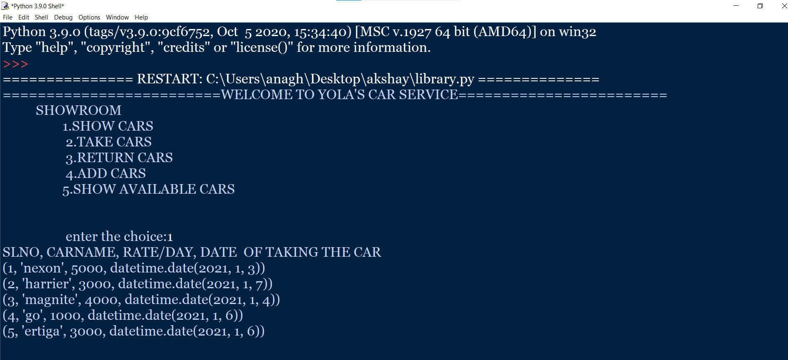

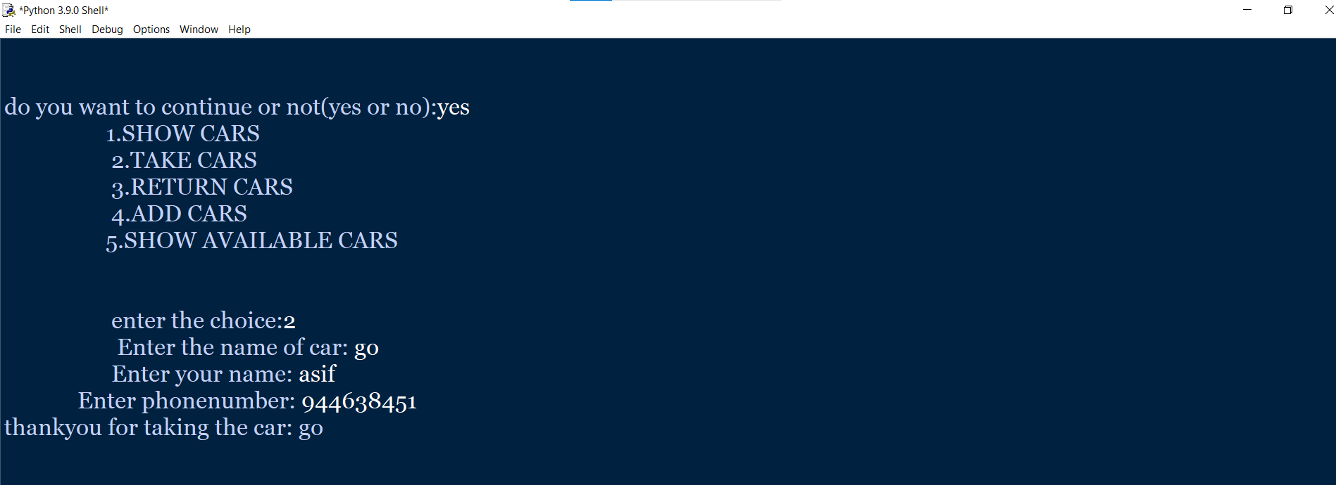

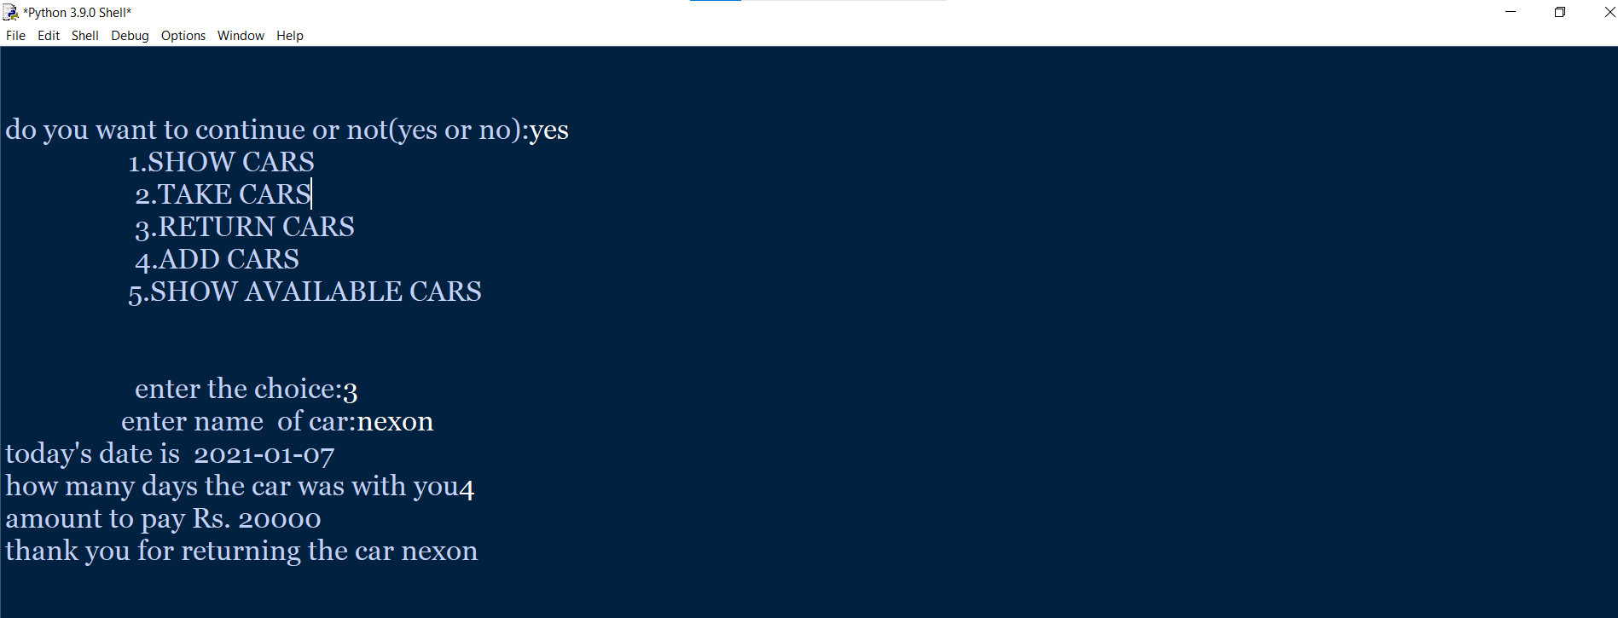

|  |  |  |
| --- | --- | --- |
| |  | | --- | | https://mail.google.com/mail/u/0/images/cleardot.gif | |  |

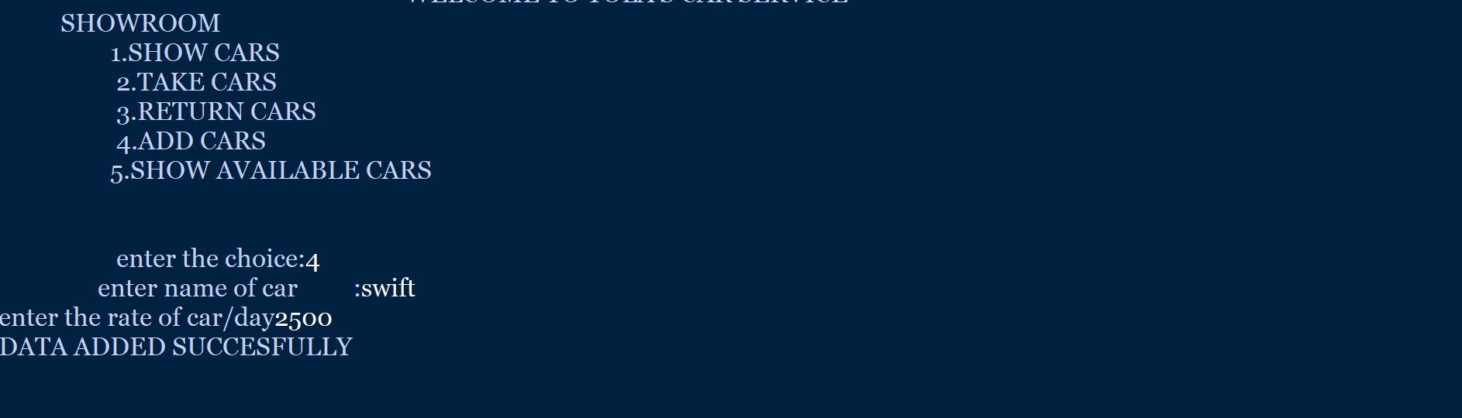

|  |
| --- |
| https://mail.google.com/mail/u/0/images/cleardot.gif  https://mail.google.com/mail/u/0/images/cleardot.gif |
|

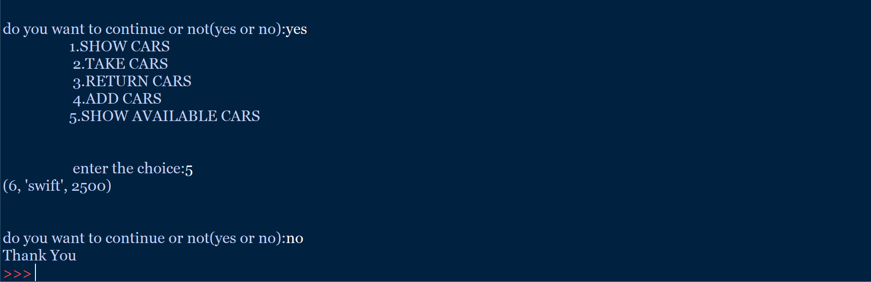

* TABLE :

